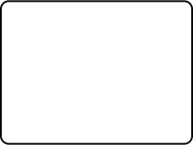
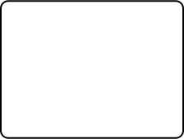

Type to enter text

Intro:

Shot 1

Shot 2

Shot 3

Shot 4

Shot 5
Type to enter text

Outro:

Shot 6

Shot 7

