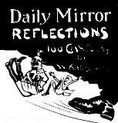  Source A  This British cartoon from 1919 shows the Kaiser booted out of Germany.  Source B  The German Weimar Republic was doomed from the start.  Written by a modern historian.  Source C  The new government had inherited a difficult situation, but to say it was doomed is unfair.  Written by a modern historian.  Task  Using your Reading List, read about the events of 1919–23, noting the things you learn which help to answer the following questions:  a. What problems faced the Weimar Republic?  b. Why was the Weimar Republic so unstable?  c. How was the Weimar Republic able to survive?  Do YOU think the Republic was ‘doomed from the start’? |  | New Words  Republic: a country without a king or queen.  Reichstag: the German parliament.  Democracy: where the government is elected.  Constitution: the way a government is set up  The Weimar Republic  At the end of October 1918, the German navy mutinied. Rebellion spread throughout the country. In November Germany was forced to drop out of the First World War. Kaiser Wilhelm II abdicated and fled the country.  A new Republic was declared. In January 1919, elections were held for a new Reichstag and in February 1919, in the town of Weimar, a new government was agreed.  Freidrich Ebert was elected President of the new Republic.  Germany did not just get a new government. The Allies made sure that Germany got a different kind of government. Before 1914, the government of Germany was almost a military autocracy; after 1919, it was a parliamentary democracy.  Germany 1919–1933  The history of Germany 1919–1933 falls into three phases:  1919–1923  At first the Weimar Republic had great difficulties:  - Left wing rebellions  - All people were angry with it  - Right-wing rebellions and terrorism  - Invasion and inflation  - Munich Putsch  1923–1929  But the Republic survived and (after Gustav Stresemann became Chancellor in 1923) did well:  - Economic Prosperity  - Foreign Policy successes  - Cultural flowering  1929–1933  After the Wall Street Crash of 1929, however, the Republic collapsed:  - Unemployment  - Nazi Party grew more powerful  - In 1933, Adolf Hitler became Chancellor

Germany’s Constitution in 1914  The Weimar Constitution of 1919  Tasks  Note how the Weimar agreement changed Germany’s constitution in the following areas:  The head of state  The government  The Reichstag  The electorate  Civil Liberties |  | Source A  There is only one master in this country. That am I. Who opposes me I shall crush to pieces.  Kaiser Wilhelm II, speaking before 1914.  Source B  The old Reichstag was a useless parliament. It could speak but it had no power.  A German politician speaking in 1926.  Source C  The German Commonwealth is a Republic. Political authority is derived from the People.  The Weimar Constitution,  6 February 1919.  Source D  The Constitution was a brave attempt to set up a democratic government… All Germans had equal rights, including the vote. Political parties were given seats in proportion to the number of votes they got. This was fair.  A modern textbook.
   | Kaiser Wilhelm II (hereditary monarch)
  appoints  ⬇ | calls/dismisses  ⬇ | controls  ⬇
  Government  Chancellor  Ministers | Reichstag  (elected)  which can stop laws proposed by the government, but cannot make laws. | The Army
   | ↑
  Electors
  Men over 25 can vote
  Bill of Rights  promises all Germans equality before the law and political and religious freedom. |  | Electors  All men and women over the age of 20 can vote.
  safeguards   | elect  ⬇
   | Freidrich Ebert (elected president) |  | Reichstag  (elected)
   | controls  ↓ |  | from which is selected  ⬇
   | The Army |  | Government  Chancellor  Ministers  must have a majority in the Reichstag, and must do as the Reichstag says.

New Words  Proportional voting: parties got Reichstag seats, not by winning constituencies, but in proportional to the number of votes they got nation-wide.  Freikorps: ‘Free Companies’ – bands of right-wing ex-soldiers  Source A  The new republic faced problems mainly as a result of signing the Treaty of Versailles  A modern textbook.  Tasks  1. List all the problems facing the Weimar republic in its early years in order of date. For each problem, decide how big a problem it was.  2. Here is a list of the factors which helped to cause the Weimar government’s problems:  - Communists  - Right-wing parties  - Officials who wanted to destroy it  - Army  - Proportional voting  - Occupation of the Ruhr  - Printing money.  For each factor:  - find the times when it caused problems for the government.  - think how it created instability in Germany.  3. Do you agree with Source A?  4. Personal research: find out all the ways in which hyperinflation affected German people. |  | Weimar problems 1919–23 [ILRIM]  1. Ineffective Constitution  The Weimar Constitution did not create a strong government:  - Article 48 of the constitution gave the President sole power in ‘times of emergency’ – something he took often.  - The system of proportional voting led to 28 parties. This made it virtually impossible to establish a majority in the Reichstag, and led to frequent changes in the government.  - The German states had too much power and often ignored the government.  - The Army, led by the right-wing General Hans von Seeckt, was not fully under the government’s control. It failed to support government during the Kapp Putsch or the crisis of 1923.  - Many government officials – especially judges – were right-wing and wanted to destroy the government. After the Kapp Putsch, 700 rebels were tried for treason; only 1 went to prison. After the Munich Putsch, Hitler went to prison for only 9 months  2. Left-wing Rebellions  The Communist KPD hated the new government:  - In Jan 1919, 50,000 Spartacists rebelled in Berlin, led by Rosa Luxemburg and Karl Leibknecht.  - In 1919, Communist Workers’ Councils seized power all over Germany, and a Communist ‘People’s Government’ took power in Bavaria.  - In 1920, after the failure of the Kapp Putsch, a paramilitary group called the Red Army rebelled in the Ruhr.  3. Right-wing terrorism  Many right-wing groups hated the new government for signing the Versailles Treaty (June 1919):  - The Kapp Putsch: in March 1920, a Freikorps brigade rebelled against the Treaty, led by Dr Wolfgang Kapp. It took over Berlin and tried to bring back the Kaiser.  - Nationalist terrorist groups murdered 356 politicians. In 1922, they assassinated Walter Rathenau, the SPD foreign minister, because he made a treaty with Russia.  4. Invasion–Inflation: the crisis of 1923  The cause of the trouble was Reparations – the government paid them by printing more money, causing inflation. In January 1923, Germany failed to make a payment, and France invaded the Ruhr. This humiliated the government, which ordered a general strike, and paid the strikers by printing more money, causing hyperinflation:  - In Berlin on 1 October 1923, soldiers calling themselves Black Reichswehr rebelled, led by Bruno Buchrucker.  - The Rhineland declared independence (21–22 October).  - In Saxony and Thuringia the Communists took power.  5. Munich Putsch  On 8–9 November 1923, Hitler’s Nazis tried to take control of Bavaria (the Munich Putsch).

Origins of the Nazi Party  1 Start  The German Workers’ Party, led by Anton Drexler, was formed in 1919. Hitler joined and soon became leader. His speeches gave people scapegoats to blame for Germany’s problems:  - the Allies,  - the Versailles Treaty and the ‘November Criminals’ (the politicians who signed it),  - the Communists and  - the Jews.  2 Twenty-Five Point Programme  In 1920, the party renamed itself the National Socialist German Workers’ Party (Nazis), and announced its Twenty-Five Point Programme.  At first, the Nazis were both nationalist (they believed in Germany’s greatness) and socialist (they believed the state should benefit everybody equally).  3. Mein Kampf  After the failure of the Munich Putsch in 1923, Hitler was sent to Landsberg jail. There he wrote Mein Kampf (My Struggle) advocating:  - National Socialism – loyalty to Germany, racial purity, equality and state control of the economy.  - Racism – the triumph of the Aryan race by armed force, because all races, especially the Jews, were inferior to the Aryan (pure German) ‘Master Race’.  - Lebensraum – to expand into Poland and Russia to get ‘Living Space’.  - Strong Government – complete obedience to the Führer.  Source D  Nazi Membership in the 1920s by social group (%)  - Skilled workers (e.g. plumbers) 33  - Businessmen (e.g. factory owners) 19  - Lower employees (e.g. shop assistants) 18  - Unskilled workers (e.g. farm labourers) 12  - Farmers 11  - Students 4  - Professionals (e.g. doctors, lawyers) 3  - Aristocrats (lords) 0 |  | 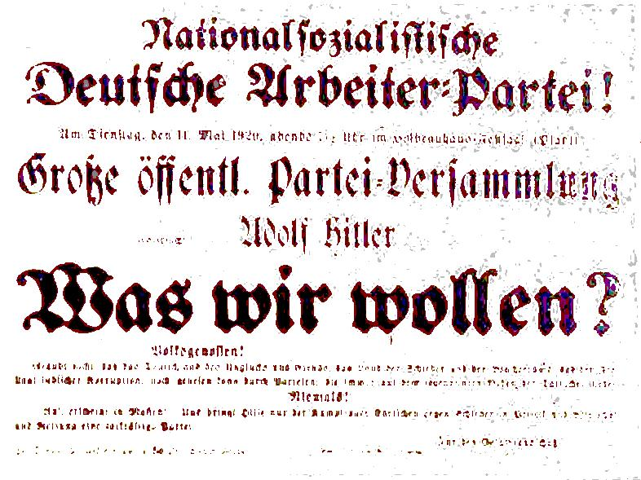  Source A  This Nazi poster, 11 May 1920, advertises a speech by Hitler: ‘What Do We Want?’ It reads: "Do not believe that other parties can save the Germany of misfortune and misery, the nation of profiteers and debt, the land of Jewish corruption!"  Source B  In the future we may be faced with problems which can be solved only by a superior race of human beings, a race destined to become master of all the other peoples and which will have at its disposal the resources of the whole world.  Hitler, Mein Kampf (1924)  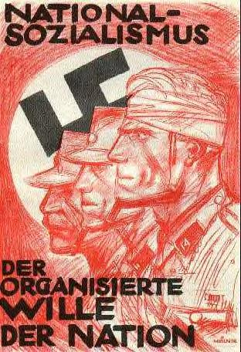  Source C  At first the Nazis were just another right-wing terrorist group. Nazi ‘Stormtroopers’ attacked opposition parties.

Source E

Basic programme of the National Socialist
German Workers’ Party

We demand:

1. The unity of all German-speaking peoples.
2. The abolition of the Treaty of Versailles.
3. Land and colonies to fee Germany’s population.
4. Only Germans can be citizens. No Jew can be a German citizen.
5. People in Germany who are not citizens must obey special laws for foreigners.
6. Only German citizens can vote, be employed or hold public office.
7. Citizens are entitled to a job and a decent standard of living. If this cannot be achieved, foreigners (with no rights as citizens) should be expelled.
8. No further immigration of non-German must be allowed. All foreigners who have come to Germany since 1914 must be expelled.
9. All citizens have equal rights and duties.
10. The first duty of a citizen is to work.
11. All payments to unemployed people should end.
12. All profits made by profiteers during the war must be shared.
13. Nationalisation of public industries*.
14. Large companies must share their profits.
15. Pensions must be improved.
16. Help for small shops and businesses; large department stores** must be closed down.
17. Property reform to give small farmers their land.
18. An all-out battle against criminals, profiteers, etc., who must be punished by death.
19. Reform of the law to make it more German.
20. Improve education so that all Germans can get a job.
21. Improve people’s health by making a law for people to do sport.
22. Abolition of the Army, and a new People’s Army in its place.
23. German newspapers must be free of foreign influence.
24. Freedom of religion.
25. Strong central government with unrestricted authority.
The Nazi Party Programme (24 February 1924)
* such as electricity and water. ** most department stores were owned by Jews.

Tasks

1. Find Nazi beliefs which would have appealed to:

a nationalist (who thought the German race was better than others)

a socialist (who wanted to help the poor people),

someone who was angry about losing the war,

someone who wanted to return to the autocratic government of the past,

someone who hated Jews.

2. Study Source D on page 5. Go through the Nazi beliefs on pages 5–6 and find things which would have appealed to each of the groups a–e.

3. Suggest reasons why not many students, doctors or lawyers joined the Nazi Party.

The Munich Putsch

Causes [Why Nazis Supported Munich Battle]
1. Weimar Weaknesses
- Constitutional flaws/ Left Wing opponents (the KPD)/ Right Wing opponents (see page 4) had all made the government weak and vulnerable.
- Invasion and inflation made the government VERY weak in 1923. Everybody was very angry with the government – there were Communist rebellions in Saxony and Thuringia.
2. Nazi Party Growing
- In the crises of 1923, the membership of the Nazi Party grew from 6,000 to 55,000.
- The Nazi Stormtroopers (SA) grew quickly, and wanted a revolution - in October, an SA leader told Hitler that, if there was not a rebellion soon, the SA would ‘sneak away’.
- Hitler became friends with General Ludendorff (a WWI hero) – he thought that the Army would follow Ludendorff in a putsch.
3. Stresemann calls off resistance
In September 1923, the German Chancellor, Stresemann, called off the general strike in the Ruhr (it was ruining Germany). This made EVERY German angry with the government.
- There was a right-wing revolt (by the ‘Black Reichswehr’) in Berlin on 1 October 1923, and the Rhineland declared independence on 21–22 October.
- The government had to proclaim a State of Emergency, Sept 1923–Feb 1924.
4. Mussolini’s Example
In 1922, Mussolini had seized control of the government of Italy by marching on Rome. Hitler hoped to copy his example.
5. Bavarian Rebellion fails
In Bavaria, the right-wing local government wanted to rebel against the Weimar Republic. Its leaders – Kahr (State Commissioner), Lossow (Local Army Commander) and Seisser (Chief of Police) – planned a march of 15,000 soldiers on Berlin. Hitler was going to help them, but on 4 Nov., they postponed the rebellion. Hitler hoped the Munich Putsch would force them to rebel.

Events
1. 8 Nov 1923
- Hitler interrupted the Beer Hall meeting, and forced Kahr, Lossow and Seisser at gunpoint to agree to support him.
- The SA took over the Army HQ (but NOT the telegraph office).
- Jews were beaten up, and the offices of the anti-Nazi Munich Post newspaper trashed.
- Kahr, released by Hitler, called in the police and army reinforcements.
2. 9 Nov 1923
- The Nazis marched on Munich. Stopped by police in Residenzstrasse, 16 Nazis were killed. Ludendorff was arrested. Hitler hid, then fled (he was arrested 2 days later).

Results [Defeat? Tell Me Something!]
1. Disaster
The Nazis were defeated and their leaders were arrested. Hitler was arrested and put on trial for treason. He was imprisoned for 9 months and forbidden to speak in public
BUT
2. Trial
Hitler turned his trial into a publicity opportunity, giving long speeches. Before the Munich Putsch, Hitler was an unknown Bavarian politician. After his trial he was a national right-wing hero. Even the judge said he agreed with Hitler, and gave him only a short prison sentence.
3. Mein Kampf
While he was in prison, Hitler wrote Mein Kampf, in which he set out his life-story and beliefs. The book sold in millions, and made Hitler the leader of the right-wing opponents of Weimar.
4. Strategy
Hitler realised that he would not gain power by rebellion. He began a new strategy – to gain power by being elected.
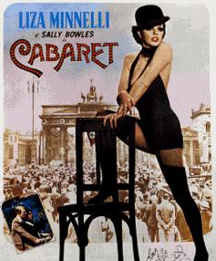  The film Cabaret was set in the Kit-Kat club in Berlin in 1930, before the Nazis took power  Source A  Stresemann was no genius. He was not the difference between pre- and post-1924 Germany. What made the difference was the Dawes Plan, and the economic prosperity that U.S. money created  Written by a modern historian.  Tasks  1. Do you agree with Source A? Why was Streseman so successful when Ebert was such a failure?  2. Personal Research: find out about the ‘Cultural Achievements of the Weimar Republic’, making notes under the following five headings – Architecture, Art, Books, Films, Cabaret.  Try to include explanations of the following in your answer: Bauhaus, Marlene Dietrich, Otto Dix, Erich Maria Remarque. |  | How did the Weimar Republic survive its problems 1919–1924? [FASS]  Although it seemed that the Weimar Republic MUST collapse, it managed to survive.  In the period 1919–1923, it used:  1. Freikorps  The SPD Defence Minister, Gustav Noske, used bands of Freikorps. They were right-wing and enjoyed putting down the Communist revolts of 1919–1920.  2. Army  The Army, led by von Seeckt, was also right-wing, and enjoyed putting down the Communist revolts of 1923.  3. Strikes  The Kapp Putsch, which was right-wing, so the Freikorps and Army refused to help. Ebert appealed to the workers of Berlin (who were left-wing), who went on strike. Berlin came to a standstill and the Putsch collapsed  In the period after 1924, a politician named Gustav Stresemann led the government (he became Chancellor in August 1923). At first he opposed the Weimar Republic, but realised the alternative was anarchy.  4. Stresemann [DIFFER]  He achieved:  • Dawes Plan, 1924  Stresemann called off the 1923 Ruhr strike and started to pay reparations again – but the American Dawes Plan gave Germany longer to make the payments (and the Young Plan of 1929 reduced the payments).  • Inflation controlled, Nov 1923  Stresemann called in all the old, worthless marks and burned them. He replaced them with a new Rentenmark (worth 3,000 million old marks).  • French leave the Ruhr, April 1924  Stresemann persuaded the French to leave.  • Foreign Affairs  In 1925, Stresemann signed the Locarno Treaty, agreeing to the loss of Alsace-Lorraine. In 1926, Germany was allowed to join the League of Nations. Germany had become a world power again.  • Economic Growth  Germany borrowed 25,000 million gold marks, mainly from America. This was used to build roads, railways and factories. The economy boomed and led to prosperity. Cultural life also boomed (the Roaring Twenties).  • Reforms  Stresemann introduced reforms to make life better for the working classes - Labour Exchanges (1927) and unemployment pay. Also, 3 million new houses were built

Weimar Art and Cinema in the 1920s  1 Expressionism emerged as an 'avant-garde movement' in poetry and painting before the First World War, being appreciated by a mass audience, having its popularity peak in Berlin, during the 1920s.  - The Expressionist stress on the individual perspective was also a reaction to positivism and other artistic movements such as naturalism and impressionism.  - In general the term expressionism refers to art that expresses emotion.  2. Many people focus exclusively on the despair that came out of World War I. The intense innovation of Weimar is related precisely to these factors. There was despair in abundance to be sure. Two million Germans died in World War I, 4 million were wounded, and men who came back were often severely wounded, both physically and psychologically.  a. To a certain extent, that intense instability of economy, society and politics fuelled this deep intellectual engagement with the problems of living in the modern age.  3. German expressionist films were prevalent in the 1920s. Amongst the most well remembered are films such as The Cabinet of Dr Caligari (Robert Weiner, 1920), Nosferatu (F.W. Murnau, 1922), Metropolis (Fritz Lang, 1927) and Sunrise (F.W. Murnau, 1927). These films were united by highly stylized visuals, strange asymmetrical camera angles, atmospheric lighting and harsh contrasts between dark and light. Shadows and silhouettes were an important feature of expressionism, to the extent that they were actually painted on to the sets in The Cabinet of Dr Caligari.  a. The story lines of German expressionist films matched the visuals in terms of darkness and disillusionment. Often sombre in mood and featuring characters from a corrupt underworld of crime, the films’ dramatic effects produced motifs of claustrophobia and paranoia. The same words could be used to describe 1940s Hollywood film noir, a genre hugely influenced by German expressionism. The themes and visual style of German Expressionism are later widely used in horror and fantasy stories, crime thrillers, melodramas, social dramas and historical epics to create the sombre mood. American Film Noir which centers on the corrupt underworld of crime was put under the direct influence of German Expressionism. |  | 1. Otto Dix, who created this work in 1920, was one of the prominent German artists of the Weimar Republic  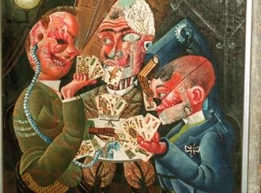  2. Nosferatu, eine Symphonie des Grauens is a classic 1922 German Expressionist horror film.  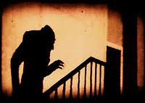  3. Metropolis is set in a futuristic urban dystopia. Metropolis is concerned with wider cultural and political issues, evidenced visually as well as thematically. The film’s social preoccupations have been described as a  commentary on the political situation that existed in Germany at the time, but also served as a warning of where Germany was heading in the future.  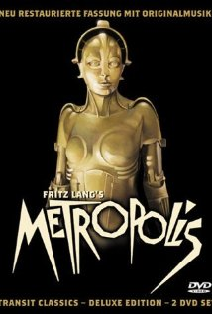
The Nazi Party in the Wilderness, 1924-1929  1 Elections and decline  After the failure of the Munich Putsch, Hitler decided that he would have to get power by being elected, rather than by rebellion. However, he was banned from speaking until 1928. The prosperity of the Stresemann years, also, meant that the Nazi’s message became less appealing, and the party lost support:  2 Reorganising the Party  In this period, however, Hitler set about reorganising the Party. He put in place many of the things which helped it take power after 1928.  - He reduced the number of Stormtroopers (SA) and set up the SS, a personal bodyguard fanatically loyal to himself.  - He set up a network of local parties. He merged with other right-wing parties, then took them over.  - He set up the Hitler Youth, which attracted young people to the party.  - He put Josef Goebbels in charge of propaganda. Goebbels and Hitler believed that the best way to get the support of the masses was by appealing to their feelings rather than by argument. They waged a propaganda campaign using posters, leaflets, radio and film, and organised  - He cultivated the support of wealthy businessmen promising them that, if he came to power, he would destroy Communism and the Trade Unions. This gave him the finance to run his campaigns. |  | 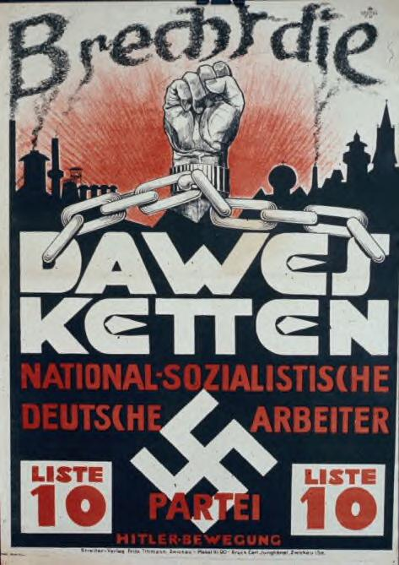  Source A  This Nazi poster from the 1928 election reads ‘Break the Dawes chains’.  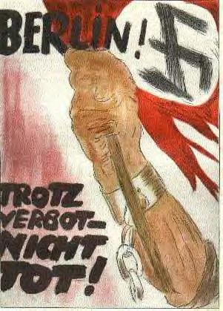  Source B  This Nazi poster c.1927 reads ‘Despite the Ban, not dead’. This poster was drawn by "Mjölnir," (real name was Hans Schweitzer). He set new standards of publicity (see p.5).  Tasks  1. Draw a graph to show how the Nazis fared in elections, 1924-28.  2. Why did the Nazis do so badly, 1924-28?
  Date of Election | Jan-19 | Jun-20 | May-24 | Dec-24 | May-28 | Sep-30 | Jul-32 | Nov-32 | Mar-33
  SPD Social Democrats | 165 | 102 | 100 | 131 | 153 | 143 | 133 | 121 | 120
  Communists KPD/USPD | 22 | 88 | 62 | 45 | 54 | 77 | 89 | 101 | 81
  Centre Party (Catholics) | 91 | 64 | 65 | 69 | 62 | 68 | 75 | 70 | 74
  DDP (Democrats) | 75 | 39 | 28 | 32 | 25 | 20 | 4 | 2 | 5
  Right-wing parties (BVP/ DVP/DNVP) | 63 | 157 | 156 | 174 | 134 | 90 | 66 | 83 | 72
  NSDAP (Nazis) |  |  | 32 | 14 | 12 | 107 | 230 | 196 | 288
  Others | 7 | 9 | 29 | 29 | 51 | 72 | 11 | 12 | 7
  Total Deputies | 423 | 459 | 472 | 493 | 491 | 577 | 608 | 584 | 647

Source A  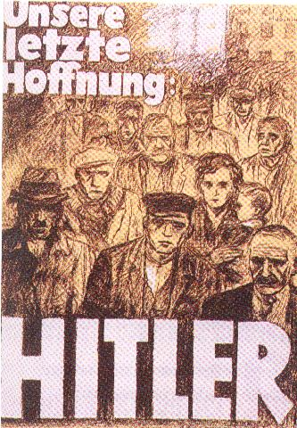  This poster of 1932 says: ‘Hitler – our last hope’  Source B  Number of Unemployed  1928 2 million  1929 2.5 million  1930 3 million  1931 5 million  1932 6 million  Draw a graph to show the number of unemployed AND the number of Reichstag seats won by the Nazis, 1928–1932 (page 9). What do you notice?  Source C  He was holding the masses, and me with them, under an hypnotic spell by the sheer force of his beliefs. His words were like a whip. When he spoke of the disgrace of Germany, I felt ready to attack any enemy.  Karl Ludecke, an early follower of Hitler (1924).  Source D  Of course, I was ripe for this experience. I was a man of 32, weary with disgust and disillusionment, a wanderer seeking a cause, patriot seeking an outlet for his patriotism.  Karl Ludecke, an early follower of Hitler (1924).  Source E  There were simply not enough Germans who believed in democracy and individual freedom to save the Weimar republic.  Written by the modern historian S Williams.  Source F  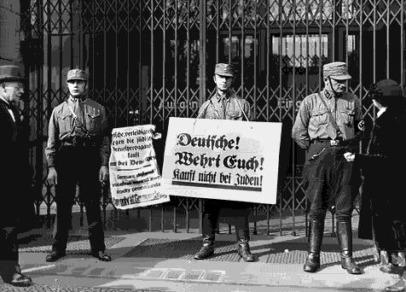  SA men stop people going into a Jewish shop.  Tasks  Write an essay ‘Why did Hitler rise to power?’  For each paragraph  - State the point  - Find some evidence (either from this page, or the pages referenced)  - Explain how this helped him come to power.  Finish with a paragraph explaining which were the most important factors. |  | Why did Hitler come to power?  [LIMP PAPER]  The story of why Hitler came to power is about the reasons why the German people lost their senses and allowed a vicious madman to come to power. What could have brought this about?  All the following were present in the 1920s:  1. Long-term bitterness (see page 4)  Deep anger about the First World War and the Treaty of Versailles created an underlying bitterness to which Hitler’s viciousness and expansionsim appealed, so they gave him support.  2. Ineffective Constitution (see page 4)  Weaknesses in the Constitution crippled the government. In fact, there were many people in Germany who wanted a return to dictatorship. When the crisis came in 1929–1933 – there was no one who was prepared or able to fight to stop Hitler.  3. Money (see page 9)  The financial support of wealthy businessmen gave Hitler the money to run his propaganda and election campaigns.  4. Propaganda (see page 9)  Nazi propaganda persuaded the German masses to believe that the Jews were to blame and that Hitler was their last hope.  5. Programme (see pages 5–6)  Hitler promised everybody something, so they supported him.  6. Attacks on other parties (see page 5)  The Stormtroopers attacked people who opposed Hitler. Many opponents kept quiet simply because they were scared of being murdered – and, if they were, the judges simply let the Stormtroopers go free (see point 2).  7. Personal Qualities  Hitler was a brilliant speaker, and his eyes had a peculiar power over people. He was a good organiser and politician. He was a driven, unstable man, who believed that he had been called by God to become dictator of Germany and rule the world. This kept him going when other people might have given up. His self-belief persuaded people to believe in him.  After 1929, however, two further factors brought Hitler to power:  8. Economic Depression  After the Wall Street Crash of 1929, the US called in its loans to Germany, and the German economy collapsed. The Number of unemployed grew; people starved on the streets. In the crisis, people wanted someone to blame, and looked to extreme solutions – Hitler offered them both, and Nazi success in the elections grew.  Germans turned to Nazism because they were desperate. The number of Nazi seats in the Reichstag rose from 12 in 1928 to 230 in July 1932.  9. Recruited by Hindenburg  In November 1932 elections the Nazis again failed to get a majority of seats in the Reichstag. Their share of the vote fell – from 230 seats to only 196. Hitler contemplated suicide. But then he was rescued by Hindenburg.  Franz von Papen (a friend of Hindenburg) was Chancellor, but he could not get enough support in the Reichstag. Hindenburg and von Papen were having to govern by emergency dcree under Article 48 of the Constitution. They offered Hitler the post of vice-Chancellor of he promised to support them.  Hitler refused – he demanded to be made Chancellor. So Von Papen and Hindenburg took a risk. On 30 January 1933 Hindenburg made Hitler Chancellor. He thought he could control Hitler – how wrong he was.  In the end, Hitler did not TAKE power at all – he was given it.  Source G  Hitler’s financiers  Many industrials bankrolled the Nazis, including allegedly:  - Hjalmar Schacht, Head of the Reichsbank, organised fund-raising parties for Hitler.  - Fritz von Thyssen, the German steel businessman  - Alfried Krupp, the owner of Krupp steel firm  - Emil Kirdorf, the coal businessman  - IG Faben, the German chemicals firm, gave half the funds for the 1933 elections  - The German car firms Skoda and Opel  - Schroeder Bank – on Jan. 3, 1933, Reinhard Schroeder met Hitler and asked him to form a government.  And many foreign firms including:  - Henry Ford of Ford Motors. Hitler borrowed passages from Ford's book The International Jew to use in Mein Kampf and had a picture of Ford on the wall of his office.  - Union Banking Corporation, New York (George Bush’s great-grandfather was president of the Corporation)  - WA Harriman and Co., the American shipping and railway company (George Bush’s grandfather was vice-president)  - Irenee du Pont, head of the American firm General Motors; he advocated the creation of a super-race by spinal injections to enhance children of ‘pure’ blood.

Eight Steps to Becoming Dictator
1 Reichstag Fire - 27 Feb 1933  The Reichstag (the German Parliament) burned down. A Dutch Communist named van der Lubbe was caught red-handed with matches and fire-lighting materials. Hitler used it as an excuse to arrest many of his Communist opponents, and as a major platform in his election campaign of March 1933. The fire was so convenient that many people at the time claimed that the Nazis had burned it down, and then just blamed the Communists. Modern historians, however, tend to believe that van der Lubbe did cause the fire, and that Hitler just took advantage of it.  2 General Election - 5 March 1933  Hitler held a general election, appealing to the German people to give him a clear mandate. Only 44% of the people voted Nazi, which did not give him a majority in the Reichstag, so Hitler arrested the 81 Communist deputies (which did give him a majority). Goering become Speaker of the Reichstag.  3 Enabling Act - 23 March 1933  The Reichstag voted to give Hitler the power to make his own laws. Nazi stormtroopers stopped opposition deputies going in, and beat up anyone who dared to speak against it.  The Enabling Act made Hitler the dictator of Germany, with power to do anything he liked - legally.  4 Gestapo - 26 April 1933  The Nazis took over local government and the police. The Nazis started to replace anti-Nazi teachers and University professors. Hitler set up the Gestapo (the secret police) and encouraged Germans to report opponents and 'grumblers'. Tens of thousands of Jews, Communists, Protestants, Jehovah's Witnesses, gypsies, homosexuals, alcoholics and prostitutes were arrested and sent to concentration camps for 'crimes' as small as writing anti-Nazi graffiti, possessing a banned book, or saying that business was bad.  5 Trade Unions banned - 2 May 1933  The Trade Unions offices were closed, their money confiscated, and their leaders put in prison. In their place, Hitler put the German Labour Front which reduced workers' pay and took away the right to strike.  6 Opposition banned - 14 July 1933  The Law against the Formation of Parties declared the Nazi Party the only political party in Germany. All other parties were banned, and their leaders were put in prison. | 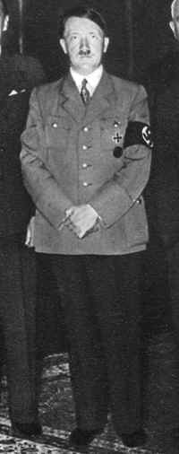  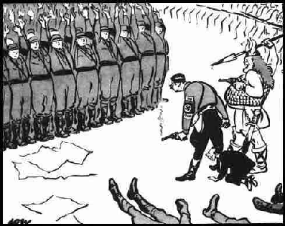  This David Low cartoon from July 1934 shows Hitler (with a smoking gun) and Goering (shown as Thor, the God of War) glowering at - not the traditional Nazi salute - but terrified SA men with their hands up. The caption reads: 'They salute with both hands now'.  Goebbels is shown as Hitler's poodle.

7 Night of the Long Knives - 30 June 1934
The SA were the thugs who Hitler had used to help him come to power. They had defended his meetings, and attacked opponents. By 1934 there were more than a million of them.
Historians have often wondered why Hitler turned on the SA. But Hitler was in power in 1934, and there was no opposition left - the SA were an embarrassment, not an advantage. Also, Rohm, the leader of the SA, was talking about a Socialist revolution and about taking over the army. On the night of 30 June 1934 - codeword 'Hummingbird - Hitler ordered the SS to kill more than 400 SA men.

8 Fuhrer - 19 August 1934
When Hindenburg died, Hitler took over the office of President and leader of the army (the soldiers had to swear to die for Adolf Hitler personally). Hitler called himself 'Fuhrer'.

Seven Ways to Control Germany

1 One-Party State  The Enabling Act (23 March 1933) Hitler was the all-powerful Fuhrer of Germany. The Law against the Formation of Parties (14 July 1933) declared the Nazi Party the only political party in Germany. It was an offence to belong to another Party. All other parties were banned, and their leaders were put in prison. Nazi Party members, however, got the best jobs, better houses and special privileges. Many businessmen joined the Nazi Party purely to get orders.  2 Terror  The Nazis took over local government and the police. On 26 April 1933, Hitler set up the Gestapo (the secret police) and the SS, and encouraged Germans to report opponents and 'grumblers'. Tens of thousands of Jews, Communists, gypsies, homosexuals, alcoholics and prostitutes were arrested and sent to concentration camps for 'crimes' as small as writing anti-Nazi graffiti, possessing a banned book, or saying that business was bad.  On the Night of the Long Knives (13 June 1934) Hitler used his legal power to assassinate all his opponents within the Nazi Party,  3 Propaganda  The German people were subjected to continual propaganda, under the control of Josef Goebbels. It was the cult of personality - everything was organised to make Germans permanently grateful to Adolf Hitler. Germans were made to feel part of a great and successful movement - in this respect the 1936 Olympic Games were a propaganda coup.  The Nazis used the most up-to-date technology to get their message across. Find the key methods of Nazi propaganda in the wordsearch:  4 Youth  'When an opponent declares, 'I will not come over to your side', I calmly say, 'Your child belongs to us already'. The Nazis replaced anti-Nazi teachers and University professors, and school lessons included hidden indoctrination - requiring children to calculate how much mentally disabled people cost the state, or to criticize the racial features of Jewish people.  German boys were required to attend the Hitler Youth, which mixed exciting activities, war-games and Nazi indoctrination. German girls went to the BDM and learned how to be good mothers, and to love Hitler.  5 Workforce  Hitler banned all Trade Unions on 2 May 1933. Their offices were closed, their money confiscated, and their leaders put in prison. In their place, Hitler put the German Labour Front which reduced workers' pay and took away the right to strike. The National Labour Service sent men on public works programmes. To keep the workers happy, the Nazis set up the Strength through Joy movement, which offered good workers picnics, free trips to the cinema and (for the very few) free holidays.  6 Religion  Hitler signed a Concordat with the Pope, agreeing to leave the Roman Catholic Church alone if it stayed out of politics - so most Catholics were happy to accept the Nazi regime. Protestants and Jehovah's Witnesses - if they opposed the Nazis - were sent to concentration camps.  7 Racism  The Nazi regime was from the start based on anti-semitism. The Racial Purity Law (15 September 1935) took away German citizenship from the Jews, and forbade sex between Germans and Jews. Other key dates include Kristallnacht (November 1938) and the Wansee Conference (January 1942). Many Germans approved of this racism. | 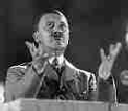  "Ein Volk, Ein Reich, Ein Fuhrer!" - one people, one empire, one leader.  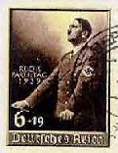  Even stamps encouraged Germans to idolise Hitler

How did Nazi rule affect the Germans?

1 Nazi Party members
- were especially happy - they got all the best houses, preferential treatment, good jobs in the government and power over other people

2 Ordinary People

Source A
We all felt the same, the same happiness and joy. Things were looking up. I believe no statesman has ever been as loved as Adolf Hitler was then.
It’s all come flooding back to me. Those were happy times.
A German farmer, Luise Essig, remembering life in Nazi Germany

For ordinary people, life was good:  - full employment (work programmes/ Strength through Joy) gave prosperity and financial security - many observers stated that there seemed to be no poverty in Germany,  - full employment (work programmes/ Strength through Joy) gave prosperity and financial security - many observers stated that there seemed to be no poverty in Germany,  - law and order (few people locked their doors),  - autobahns improved transport,  - frequent ceremonies, rallies, colour and excitement,  - Nazi propaganda gave people hope,  - Nazi racial philosophy gave people self-belief  - Trust in Adolf Hitler gave a sense of security (one German woman told the American reporter Nora Wall: 'He is my mother and my father. He keeps me safe from all harm.') | There were few drawbacks:  - Wages fell, and strikers could be shot - the Nazis worked closely with the businessmen to make sure that the workforce were as controlled as possible.  - Loss of personal freedoms (eg freedom of speech).  - All culture had to be German - eg music had to be Beethoven or Wagner or German folk songs - or Nazi - eg all actors had to be members of the Nazi party/ only books by approved authors could be read.
3 Women
The Nazis were very male-dominated and anti-feminist.
Nazi philosophy idealised the role of women as child-bearer and creator of the family:  - The Law for the Encouragement of Marriage gave newly-wed couples a loan of 1000 marks, and allowed them to keep 250 marks for each child they had.  - Mothers who had more than 8 children were given a gold medal. | But not all women were happy with the Nazi regime:  - Job-discrimination against women was encouraged. Women doctors, teachers and civil servants were forced to give up their careers.  - Women were never allowed to serve in the armed forces - even during the war.
The perfect Nazi family 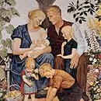

4 Youth
Most German young people were happy.  - Nazi culture was very youth-oriented.  - The HJ provided exciting activities for young boys.  - The HJ and the BDM treated young men and women as though they were special, and told then they had knew more then their parents.  - Many parents were frightened that their children would turn them into the Gestapo, which gave young people a power that they enjoyed. | But not all young people were happy with the Nazi regime:  - Some girls were unhappy with the emphasis on the three Cs (Church, children, cooker). Girls who were regarded as true Aryan girls were sent off to special camps where they were bred (like farm animals) with selected 'Aryan' boys.  - Towards the end of the war, youth gangs such as the Eidelweiss Pirates grew up, rejecting the HJ and Nazi youth culture, drinking and dancing to American jazz and 'swing' music. In Cologne in 1944 they sheltered army deserters and even attacked the Gestapo. If they were caught, they were hanged.
5 Opponents
But remember that:  - Many Germans welcomed this because it brought political stability after the Weimar years | The Nazi's used 'fear and horror' against anyone who disapproved of their regime:  - Hitler banned all Trade Unions on 2 May 1933. Their offices were closed, their money confiscated, and their leaders put in prison.  - Communists were put into concentration camps or killed.  - Many Protestant pastors such as Dietrich Bonhoffer were persecuted and executed.  - Each block of flats had a 'staircase ruler' who reported grumblers to the police - they were arrested and either murdered, or sent to concentration camps.  - Children were encouraged to report their parents to the Gestapo of they criticized Hitler or the Nazi party.
6 Untermensch
But note that:  - Many Germans approved of this. | The Nazi regime despised many groups it thought were racially or socially inferior (untermensch = subhuman) - people they called the 'germs of destruction'. Groups which were persecuted and killed included:  - Black people, who were sterilized and killed.  - Jews, such as Anne Frank, who the Germans systematically persecuted, put into concentration camps, used for medical experiments and, in the end, devised the Final Solution of genocide.  - Gypsies, who were treated as badly as the Jews - 85% of Germany's gypsies were killed.  - 5000 mentally disabled babies were killed 1939-45.  - 72,000 mentally ill patients were killed 1939-41.  - Physically disabled people and families with hereditary illness were sterilized - 300,000 men and women were sterilized 1934-45.  - Beggars, homosexuals, prostitutes, alcoholics, pacifists, hooligans and criminals were also regarded as anti-social, and they were put in concentration camps.

Revision Questions
- When was the Kiel mutiny which precipitated Germany’s defeat in World War I?
- When and where was the Weimar Republic declared?
- Who became President of the Weimar Republic in 1919?
- List FIVE differences in the Constitution, 1914 versus 1919.
- What was the Reichstag?
- What did the Weimar’s Bill of Rights say?
- Name FIVE problems the Weimar government faced, 1919-1923
- Which article of the Constitution gave emergency powers to the President?
- What is ‘proportional voting’ and how did it damage the Weimar Republic?
- Who was leader of the army in the 1920s, and how did he damage the Republic?
- Who led the Spartacist Revolt in 1919?
- Where did a Communist ‘People’s Government’ come to power in 1919?
- What Communist group rebelled in the Ruhr in 1920?
- Who led a Freikorps brigade to rebel against the Versailles Treaty, March 1920?
- Which SPD foreign minister was assassinated in 1922, and why?
- Why did many right-wing troublemakers get away with their crimes?
- Where did the French invade in January 1923?
- What was ‘hyperinflation’, and what caused it?
- What did Bruno Buchrucker do?
- Who founded the Nazi party?
- Which FOUR groups of people did Hitler blame for Germany’s problems?
- Give SEVEN causes of the Weimar government’s problems
- How many of the 25-points of the programme of the Nazi Party can you remember?
- What were the he Four principles of Mein Kampf?
- Who were the thugs of the Nazi party who terrorised opponents?
- Which FIVE groups supplied most supporters of the Nazis?
- Give FIVE causes of the Munich Putsch
- Which right-wing group rebelled in Berlin in 1923?
- What three Bavarian leaders did Hitler try to get to join the Munich Putsch?
- List FOUR results of the Munich Putsch
- Suggest FOUR reasons the Weimar republic survived
- List SIX things Stresemann achieved
- For what were the following famous: Gropius, Marlene Dietrich, Otto Dix and Erich Maria Remarque?
- What modern film was set in 1930 Berlin?
- Explain FIVE ways Hitler reorganised the Nazi Party, 1924–1928.
- How did Hitler appeal to German businessmen?
- Name FOUR German firms or individuals who financed Hitler.
- Name TWO non-German firms or individuals who financed Hitler.
- Who drew the Nazi posters?
- What were the NINE reasons Hitler came to power in 1933
- How many unemployed were there in Germany in 1928 and in 1932?
- How many seats did the Nazi party have in the Reichstag in 1928 and in 1932?
- Suggest FOUR personal qualities which helped Hitler come to power.
- What caused the economic depression in 1929?
- Who was Chancellor in 1932?
- Who was president in 1932?
- What date did Hitler become Chancellor?
- List the EIGHT steps by which Hitler turned his position as Chancellor into that of Fuhrer?
- List SEVEN ways the Nazis kept control of the German people?
- List SIX German social groups affected by the Nazi regime.
Top of Form
Bottom of Form
Bottom of Form

