EUROPE AFTER NAPOLEON – Reaction
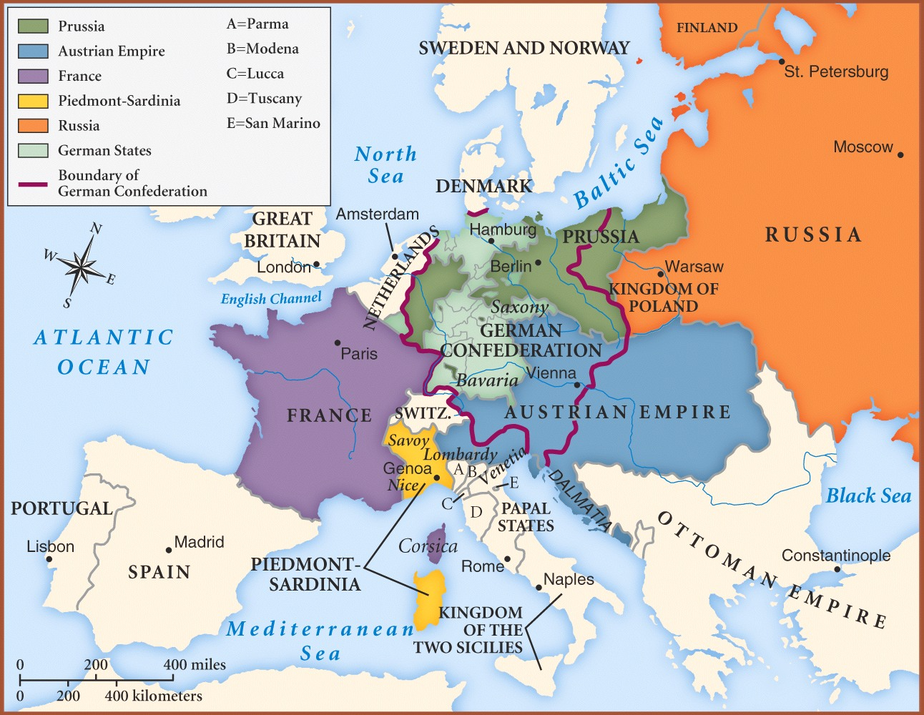

At the Congress of Vienna those nations who had joined together to defeat Napoleon tried to reestablish the traditional order in Europe. The leaders of the nations were determined to put the “rightful rulers” back and to see that France did not cause any more trouble. Boundaries were changed so that France was surrounded by a number of strong buffer states which were to prevent future aggression.

Nationalism and liberalism, two great forces in the post-Napoleon world, played only a small role at the Congress of Vienna. Diplomats met there to restore legitimate rulers to power and reshuffle territories to maintain a balance of power. Metternich, the leader of the Congress who dominated Europe for years, worked to suppress liberal and nationalistic movements that threatened absolutism.

In redrawing the map of Europe, the men at the Congress of Vienna followed the principles of legitimacy and compensation in deciding the boundaries of countries. Legitimacy refers to the practice of returning the former kings (or their families) to power. (They were considered the “legitimate” rulers!) Compensation was a way of rewarding nations who had fought Napoleon. Land was taken away from supporters of Napoleon, and given to the victors.

It is important to note that in making the decisions about the territory and the rulers, no consideration was given to the people who lived in the area. Their feelings, customs, language, or religion were not thought to be important, In this oversight, the men and Vienna made a serious mistake. Napoleon had aroused nationalism in the people, and it could not be turned off. The ideas of the Enlightenment had convinced many that they had the right in their choice of governments. In the period that followed the Congress of Vienna, the feelings of nationalism and liberalism caused many revolts and revolutions. Was the congress a good thing or bad? Well that point is for the historians to decide. Evaluating how historians have analyzed past events is known as “historiography.” (When you study 'historiography' you do not study the events of the past directly, but the changing interpretations of those events in the works of individual historians.)
The Congress of Vienna was frequently criticized by 19th century and more recent historians for ignoring national and liberal impulses, and for imposing a stifling reaction on the continent. Indeed, this criticism was already voiced by the Whig’s ( an early political party) opposition in the UK as soon as the Congress had concluded. The Congress of Vienna was an integral part in what became known as The Conservative Order in which peace and stability were traded for the liberties and civil rights associated with the French Revolution.
In the twentieth century, though, many historians have come to admire the work of the statesmen at the Congress, whose work, it was said, had prevented another European general war for nearly a hundred years (1818-1914). Among these is Henry Kissinger, whose doctoral dissertation was on the Congress of Vienna.

Age of revolutions- Post Vienna
(Taken from Exploring World History)

Ideas are like living things – once they get started, they continue to grow. Two important ideas had been planted in Europe by the French Revolution of 1789: DEMOCRACY and NATIONALISM. To the people of Europe, democracy meant having a say in your government. Nationalism was the pride people fent when united by a common language and history. It also meant loyalty to the place/country where they lived.

For more than thirty years Prince Metternich of Austria tried to suppress these ideas in Europe but they continued to grow, spreading from one country to another. Sometimes revolutions were staged, some successful, some not. Europe swayed back and forth from democratic revolution to suppression by monarchies in the period known as the AGE OF METTERNICH.

Revolution against the oppressive METTERNICH SYSTEM broke out all over Europe. The Metternich System consisted of replacing all of the monarchs in European countries conquered by Napoleon (legitimacy), censoring all free speech, and using military alliances to make sure that a “Napoleon” could never again upset the balanced of power 9the Concert of Europe). The armies of the Quadruple Alliance (Russia, Prussia, Austria, and Britain) put down one of the first revolutions in 1820 in Spain. Revolutions in the Italian city-states against Austrian rulers also failed at this time. Greece, however, was different. As part of the Ottoman Empire (Turkish and predominately Muslim), Greece gained the support of the Quadruple Alliance because its members were Christian and were therefore, unwilling to help suppress a revolt against a Muslim nation. Instead, they supported the Greeks and after eight years of fighting, Greece won their independence in 1829.

New revolts sprang up all over Europe in 1830. Uprising began in France, Belgium, Poland, and man of the German and Italian city-states. In France, Charles X (brother of Louis XVIII), had wiped out all democratic gains of the French Revolution and had pretty much reverted to a strong monarchy. He allowed no freedom of speech, of the press, or of religion. Charles X disbanded the parliament, which had been elected by the people. When the people of Paris began to riot in 1830, Charles was forced to leave the country. The French people then chose Louis Philppe (known as the “Citizen-King” and another member of the Bourbon family), as their new ruler.

The 1830 revolt in France was caused by the suppression of democratic rights, but the spirit of nationalism that same year cause the revolution in Belgium. The Congress of Vienna (remember Metternich?), had joined Belgium to Holland without the Belgian consent. The Belgians wanted to be independent. They considered themselves different from the Dutch as they spoke a different language (Flemish or French), were a different religion (Catholic rather than Protestant), were merchants and manufacturers rather than farmers. This difference brought on a national pride that eventually led to a rebellion. Holland and other nations on Europe finally accepted Belgium as an independent nation.

A nationalistic revolt in Poland however failed. The Congress of Vienna had given most of Poland to Russia. In 1831, the Polish people started an uprising. They wished to become independent from Russia but Czar Nicholas I put down the revolt with cruelty. Uprisings in the German and Italian city-states were also crushed at this time.

The Metternich System continued to hold back democracy and nationalism for 33 years after the Congress of Vienna, but violence again broke out in Europe in the 1840s. It began in 1848 with a new revolt in Vienna, but violence again broke out in Europe in 1848 with a new revolt in France. The workers of Paris became tired of the dishonest and undemocratic government of Louis Philippe. They started a short, but bloody revolution. Thousands of workers lost their lives. Louis Philippe escaped France and the Second French Republic was set up (remember, the First French Republic was under Robespierre).

News of the French revolt spread throughout Europe. Revolts started in Austria, Hungary, Prussia, and many of the Italian city states. Some of these uprisings were for more democratic self-government, while others were for national independence. Many were for both democratic reforms and independence.

When revolution broke out in Austria (Metternich’s own country), Metternich’s home was set on fire by rioters. Metternich hid in a laundry wagon and then escaped to England. The Austrian army, however, was able to crush the revolt and Metternich returned. The Austrian army also put down the rebellions in Hungary and the Italian city states, which were under Austria’s control at that time. In Prussia, the uprising began when the King broke his promise to grant a democratic constitution. The very well trained Prussian army also crushed it. Indeed, most of the revolutions of 1848 failed, but the Metternich System was destined to fail. As the smoke of the last 1848 revolt cleared, Europe stood at the beginning of a new era of democracy and nationalism.

Answer sheet for AGE OF REVOLUTIONS READINGS

- Read carefully what your text says about liberalism. Note that the things the liberals advocate change according to the conditions. What major beliefs did the liberals have in the period following Napoleon?

- What were the major policy aims of the leaders of Europe following Napoleon’s defeat?

- The period from 1815-1848 is called by several names: a) The Age of Metternich b) Age of Reaction c) Age of Revolution. How is each of these names representative of the period?

- What countries were the major powers at the Congress of Vienna? Who were the men representing each? Who were the tow most influential men at the Congress? What country did each represent?

- Review the political spectrum (radical liberal, moderate, conservative, reactionary.) Napoleon and the French Revolution had spread liberal ideas. The Congress of Vienna brought in the Reactionary period. Metternich is usually given as an example of the reactionary leader. Give three reasons why Metternich could be called a reactionary.

- Often it is said that the Congress of Vienna wanted to “turn the clock back”----- What does this mean? Is it true?

- Copy the chart below onto your homework paper. Fill it in with the correct answers. (be sure to give yourself enough room to give good answers)

Alliance Participants Major ideas of the alliance- goals
Quadruple : :
Alliance : :
: :
Holy : :
Alliance : :
: :
Quintuple : :
Alliance : :
: :
: :
___________ :________________:________________________________________

- How successful were these alliances?

9. In your opinion was the Congress of Vienna a “success?”

Answer all questions according to information in the reading. Be sure to give complete answers using examples from the reading.

1. What does “nationalism” mean, what does “democracy” mean?

2. Give an example of a nationalistic revolution – explain why it is “nationalistic”.

3. What is meant by the statement “revolts were suppressed”? given an example from the reading.

4. Who were the members of the Quadruple Alliance?

5. Why didn’t the quadruple alliance help stop the revolt in Greece?

6. Do you agree or disagree with the following statement? Make sure that you use that you use specific examples from the reading and lectures to support your answer. You may write your answer on the back of this paper.

“The French were responsible for the unrest in Europe during the first half of the 19th century.” (Note Metternich’s comment…”when France sneezes…”)

