The Secrets of America's Great Presidents
By Doris Kearns Goodwin
published: 09/14/2008

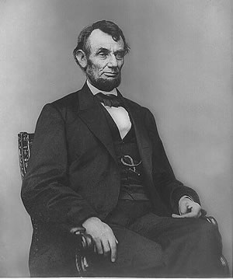
What makes a great President? As a historian, I look to the past to help predict the future. And I am convinced that Americans should consider the leadership strengths of our most successful Presidents when deciding how to cast their ballots in November. Focusing on the qualities that have made some of our leaders exceptional provides a better perspective on our current candidates than what's so often reported--mistaken words, glib replies, fundraising abilities, and TV ads. Taking Abraham Lincoln and Franklin Roosevelt as guides, I've identified 10 attributes that distinguish truly great Presidents.
1 The courage to stay strong
A President needs the ability to withstand adversity and motivate himself in the face of frustration. From childhood, Lincoln showed a determination to rise above the poverty into which he was born. Despite failure that would have felled most others, he never lost faith that if he refused to despair, he would eventually succeed. Roosevelt, by contrast, grew up with wealth, privilege, and love. His crucible came in a polio attack that left him a paraplegic at 39. While crippling his body, the paralysis expanded his sensibilities. He emerged from his ordeal with greater powers of concentration and greater self-knowledge. Far more intensely than before, he was able to put himself in the shoes of others to whom fate had dealt an unfair hand.

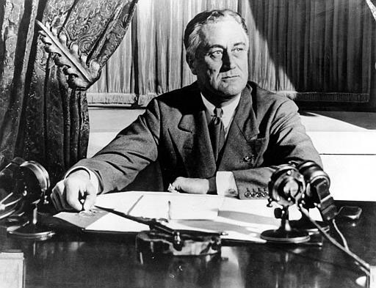
2 Self-confidence
Good leadership requires you to surround yourself with people of diverse perspectives who can disagree with you without fear of retaliation. Lincoln placed his three chief rivals for the Republican nomination in crucial positions in his Cabinet and filled the rest of his top jobs with former Democrats. His Cabinet sessions were fiery affairs, but they provided him with a wide range of advice and opinion. Similarly, FDR created a coalition Cabinet on the eve of war, bringing unsparing critics of the New Deal into key positions as Secretary of War and Secretary of the Navy. And for his Army chief of staff, he reached 34 names down the list of senior officers to appoint George Marshall, because the straight-talking general was the only one to disagree with him in a meeting.
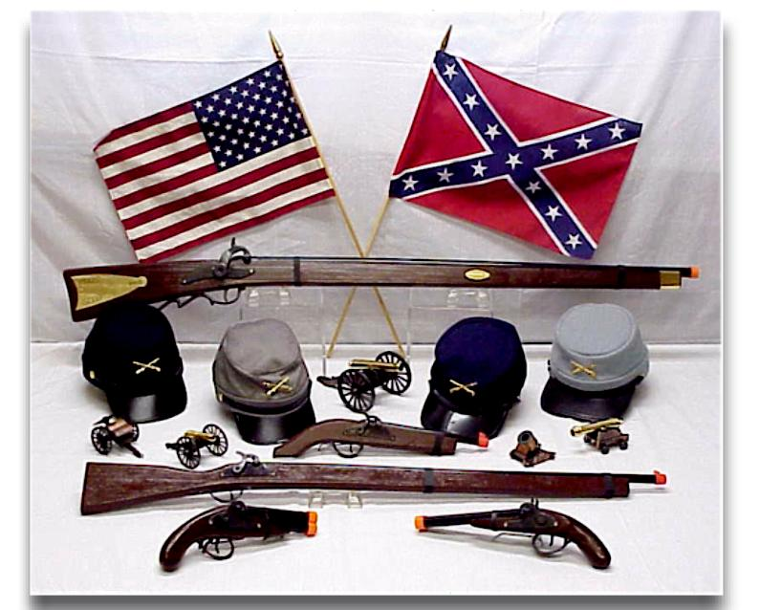
3 An ability to learn from errors
To lead successfully, you must be willing to acknowledge and learn from your mistakes. After the rout of Union forces at Bull Run, Lincoln stayed up all night writing a memo on military policy that incorporated the painful lessons he had learned. And when FDR concluded that a New Deal program was not working, he created a new one in its place, built upon an understanding of what had gone wrong.
4 A willingness to change
Conditions change, and Presidents must respond. When war came, FDR made his peace with the industrialists whose hatred he had welcomed during the New Deal. He relaxed anti-trust regulations, guaranteed profits, and brought in top business executives to run his production agencies, aware that only with their commitment could we build the planes, tanks, and ships we needed to win.
5 Emotional intelligence
A President must encourage his closest advisers to give their best and remain loyal. Lincoln shared credit for his successes and shouldered public blame for the failures of his subordinates. FDR had a remarkable capacity to transmit strength to others, to make them feel more determined to do their jobs well.
6 Self-control
Great leaders manage their emotions and remain calm in the midst of trouble. When angry with a colleague, Lincoln liked to write him a "hot letter," giving his emotions free rein. Then he would put the letter aside, knowing he would calm down and never send it. If he lost his temper, he would invariably follow up with a kind gesture. "If I was cross, I ask your pardon," he wrote to one of his generals. "If I do get up a temper I do not have sufficient time to keep it up." And on the Sunday that the Japanese attacked Pearl Harbor, Eleanor Roosevelt was struck by her husband's "deadly calm." While aides and Cabinet officers ran in and out in excitement, panic, and irritation, FDR remained at his desk, absorbing the news, deciding what to do next.
7 A popular touch
The best Presidents have an intuitive awareness of public sentiment, a sense of when to wait and when to lead. Lincoln once said that if he had issued the Emancipation Proclamation six months earlier, "public sentiment would not have sustained it." By following the gradual shift in the newspapers, by opening his office to conversations with ordinary people, by visiting troops in the field, he rightly concluded that by early 1863, the opposition was no longer "strong enough to defeat the purpose." FDR was said to possess an uncanny awareness of the hopes and fears of his countrymen and to know precisely when to move forward, when to hold back, and when to deliver one of his fireside chats.
8 A moral compass
Only strong leaders have the courage and integrity to follow their convictions when the risk of losing popular support is great. In mid-1864, top Republicans warned Lincoln that unless he renounced emancipation as a condition, the Confederates never would agree to peace talks, without which he had no chance of re-election. Yet Lincoln turned his party's leaders away without a second thought. "I should be damned in time and in eternity," he wrote, if he chose to conciliate the South over the slaves to whom he had pledged freedom. FDR chose in 1940 to supply England with what little America had in the way of weapons. In so doing, he drew the wrath of isolationists, liberals, and educators. His own generals warned that he so risked American security that he might be impeached or "found hanging from a lamppost" if England fell and Hitler used our captured weapons against us. Believing England's survival critical to the preservation of Western civilization, FDR was willing to take that risk.
9 A capacity to relax
FDR held a White House cocktail hour every evening. Its cardinal rule: Nothing was to be said of politics or war. Guests were to gossip, tell funny stories, and reminisce so that everyone could enjoy a few precious hours away from the pressures of the day. Lincoln possessed a life-affirming sense of humor and a legendary ability to tell long, winding tales that allowed him "to whistle off sadness." He laughed, he explained, so he did not weep.
10 A gift for inspiring others
One of the key qualities of a great President is his ability to communicate national goals to the people and to educate and shape public opinion. Both Lincoln and FDR conveyed their convictions with stories and metaphors, as well as a profound sense of history and a love of poetry and drama. When Lincoln delivered his second inaugural address, the North was on the verge of winning the Civil War. Yet he avoided a triumphal message. Knowing that his next challenge was to return the defeated South to the Union, he suggested that the sin of slavery was shared by both sides and called on his countrymen "with malice toward none; with charity for all...to bind up the nation's wounds." FDR's first inaugural address, delivered at the height of the Depression, conveyed a clear understanding of the difficulties the nation faced and projected such serene confidence in the fundamental strength of his country that he renewed the hope of millions.
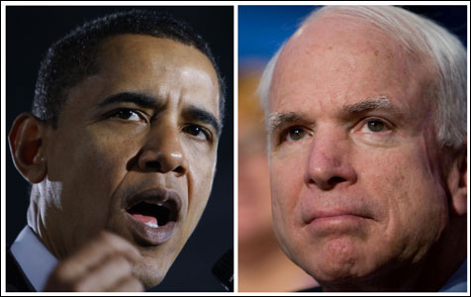
I hope that as this campaign reaches its end, we can all move beyond the superficial "issues" that now play too large a role in Presidential politics. Let us look closely at the leadership styles of John McCain and Barack Obama and analyze their strengths and weaknesses in relation to our greatest leaders. It will take imagination to shift our present mode of thinking. Old habits die hard. But let us begin.

Doris Kearns Goodwin is the author of "Team of Rivals: The Political Genius of Abraham Lincoln." She won a Pulitzer Prize in 1995 for her book on Franklin and Eleanor Roosevelt. This article was originally printed in Parade Magazine. http://www.parade.com/articles/editions/2008/edition_09-14-2008/2President_Secrets

NAME:____________________________________________ Period:________ Date:____________

The Secrets To America’s Great Presidents

Doris Kearns mentions that there are 10 attributes that contribute to good leadership using Lincoln and FDR as her examples. In pairs, complete the following questions.

- Are there any other President or historical figures that could also be used as examples who fit the attributes that Doris Kearns-Goodwin describes? List at least two and explain why you mention them.

- Are there any attributes that were not mentioned in the list? Think of at least two and explain why they should be included.

- in your opinion, what attributes are given too much attention by the public and the media and which attributes should be emphasized more? Explain your answer.

- Referring to the 10 attributes, how do President Bush and President Obama use them? Use specific examples.

BUSH:

EXAMPLES:

OBAMA:

EXAMPLES:

5.) Who do you think is the greatest president in history? Why?

