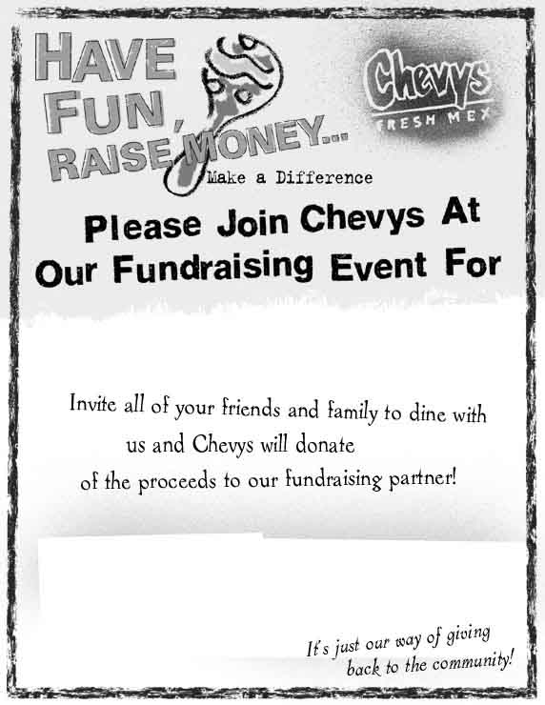
Date: Monday December 11th

TIME: 6PM-10PM

ADDRESS: San Jose Westgate
1502 Saratoga Avenue
San Jose, CA 95129

25%

The Global Ischemia Foundation
Make sure to present this flyer with the bill!

